FY 2003 OPERATIONAL PLAN
Upper Cook inlet Salmon personal use harvest monitoring
Principal Investigators: | Dora Sigurdsson, Fishery Biologist II
 | Kirk Brogdon, Analyst Programmer III
Assisting Personnel: | Pat Hansen, Biometrician III
 | Robert Walker, Analyst Programmer IV
 | Vacant, Administrative Clerk III
 | Margaret Nussbaum, Administrative Clerk II
 | Melissa Clark, Adminstrative Clerk II

Titles | Approval Signatures |  | Dates
Project Managers:
Consulting Biometrician
Information Management Supervisor::
Chief Biometrician:

Table of Contents
Page
List of Tables ii
List of Appendices ii
SYNOPSIS 1
Need 1
Benefits 1
Objectives 1
Procedures 1
Location 1
Budget Summary 2
INTRODUCTION 3
OBJECTIVEs 3
STUDY DESIGN 4
DATA COLLECTION 6
DATA REDUCTION 7
DATA ANALYSIS 10
SCHEDULES AND REPORTS 11
LITERATURE CITED 10
Appendix A - 2002 Upper Cook Inlet personal use Salmon Fishing Permit 10
Appendix B -Reminder letter to be mailed to nonrespondents 10
Appendix C - Cook Inlet personal use Fishing Regulations, 2002 10
APPENDIX D - KEYPUNCHING INSTRUCTIONS 23
APPENDIX E - FILE STRUCTURE FOR PERSONAL USE SALMON DATABASES 35

List of Tables
Table Page
1. Number of permits returned by mailing, 1999-2001. 10
2. Sockeye salmon harvest in the upper Cook Inlet Personal Use fishery, 1999-2001. 10

List of Appendices
Appendix Page
A1. 2002 Upper Cook Inlet personal use salmon permit. 10

B1. Reminder letter to be mailed to nonrespondents. 10

C1. Cook Inlet personal use fishing regulations, 2002. 21
D1. Keypunching Instructions. 24
E1. File structure for personal use salmon databases. 36

SYNOPSIS

Need
The Upper Cook Inlet personal use fishery is managed to provide Alaskan residents opportunity to harvest salmon for personal use. There is a set gill net fishery near the Kasilof River and dip net fisheries in the Kasilof and Kenai rivers and Fish Creek. A fishery management plan is in place to allow for fishery openings by date and to allow set levels of harvest by permit holder. All fisheries are designed to provide for sustained yield management of the resource. Monitoring of these fisheries through a permit system is essential to proper management.

Benefits
This budget provides for drafting and duplicating personal use fishery permits, mailing and phone costs for reminder notices, staffing to keypunch permit data, and staffing for analysis of participation and harvest information. This information is used to allow proper management of the resource.

Objectives
- Make permits available to all Alaskan residents who wish to participate in Upper Cook Inlet personal use fisheries;
- Estimate harvest by fishery and gear type; and,
- Estimate participation by fishery.

Procedures
Permits are required to participate in Upper Cook Inlet personal use fisheries. Permit holders must return their permits to Fish and Game by 15 August. All permit holders who fail to return their permits by this deadline will be sent a letter reminding them to report their participation and harvest data. A second follow-up reminder letter will be mailed to those who do not respond to the first letter. Data from returned permits will be keypunched, edited, and processed; producing summary reports. Appropriate methods will be used to expand data from returned permits to estimate total harvest and participation by fishery and gear type.

Location
The project will be conducted out of the Anchorage office, but will collect information from Upper Cook Inlet personal use fisheries that occur at or near the Kasilof River, Kenai River, and Fish Creek (near Wasilla).

Budget Summary
Code | Line Item | Cost
100 | Personal Services | 3504
200 | Travel | 0
300 | Contractual | 15.0
400 | Commodities | 0
500 | Equipment | 0
700 | Grants | 0
Total |  | 50.4

Budget Manager: Dora Sigurdsson, Fishery Biologist
Project Personnel: (Name, job class, months budgeted)
Kirk Brogdon | Analyst Programmer III | 2.0
Margaret Nussbaum | Administrative Clerk II | 2.0
Melissa Clark | Administrative Clerk II | 2.0
Dora Sigurdsson | Fishery Biologist II | 2.0
Total |  | 8.0

INTRODUCTION
Subsistence and personal use fishing in Cook Inlet has undergone numerous regulatory changes over the past two decades (Nelson et al. 1999), reflecting the efforts by the state and federal governments and the court system to develop a legal definition of subsistence use.
Beginning in 1996, Cook Inlet was closed to subsistence harvest of salmon, but a personal use fishery open to all Alaskan residents was developed. In 2002, four personal use salmon fisheries will be opened in upper Cook Inlet (north of Anchor Point):
- gill netting at the mouth of the Kasilof River from 16 June until closed by emergency order, usually 9 days later (on the 25th),
- dip netting at the mouth of the Kasilof River from 10 July through 5 August,
- dip netting at the mouth of the Kenai River from 10 July through 31 July, and
- dip netting at the mouth of Fish Creek from 10 July through 31 July.
A permit is required to participate in the Upper Cook Inlet personal use fisheries. One permit is required for the Kasilof, Kenai, and Fish Creek fisheries combined. These are household permits, and a household can receive only one permit per year. For residents over the age of 16, a current Alaska sport fishing license is required to obtain the permit (with the exception of those residents who are disabled veterans or over the age of 60 and therefore exempt from licensing). Fishers are allowed to harvest all species of salmon, with the exception that only one chinook salmon may be harvested from the Kenai or Kasilof rivers, and no chinook salmon may be harvested from Fish Creek. Each household is allowed 15 salmon for the head-of-household plus 10 more for each household member. The timing of the fisheries is such that the majority of the harvest is expected to be sockeye salmon.

OBJECTIVEs
- Make permits available to all Alaskan residents that wish to participate in Upper Cook Inlet personal use fisheries;
- Estimate participation (household days fished) and harvest for the Kasilof gillnet, Kasilof dip net, Kenai dip net, and Fish Creek dip. Estimates from Kasilof gillent, Kasilof dipnet, and Kenai dip net will be within 10% of true values 95% of the time and estimates from Fish Creek dipnet fishery will be within 20% of true values 95% of the time.

STUDY DESIGN
All participants in the Upper Cook Inlet salmon personal use fisheries are required to get a permit or to be named on the permit of another household member. This fishery is open to residents only. A valid resident sport fish license is required for those who wish to participate.
In 2002, vendors in the Mat-Su, Anchorage, and Kenai Peninsula area who issued 2001 Cook Inlet Personal Use Salmon permits will again issue permits. Permits will also be issued at Fish and Game offices in Palmer, Anchorage, Soldotna, and Homer. Quantities issued will be based on the number issued in 2001. The number of permits distributed by a vendor is critical for proper estimation, the project manager is responsible for maintaining accurate records and providing these to data processing staff and the project biometrician. Permit vendors and offices will be required to return the top portion of the permit to Alaska Department of Fish and Game, Sport Fish Division, Research and Technical Services (RTS) in Anchorage. This “vendor copy” will have the permit number, permit holder’s name and address, and sport license number. In 2002 the number of household members and the total allowable harvest will be added to the vendor portion of the permit. Names and addresses from the vendor copies will be used to contact permit holders that do not return their permits. Permits are sequentially numbered and vendors will be given known sequences of permits.
Some vendors most likely will fail to return vendor copies from some of the permits that they issue. Fewer than 100 vendors will be issuing permits, so it will be possible to contact all vendors at the end of the season. This should minimize the number of missing vendor copies. However, if we don’t get all the vendor copies, we will need to estimate the number of permits issued. We will get some permits returned by permit holders for which we have no corresponding vendor copy (the vendor did not return the vendor copy, but the permit holder did return the permit). We will assume that the response rate (prior to mailing the first reminder letter) among known permits from a vendor will be the same as the response rate among the permits lacking a vendor copy (the “orphan permits”). This response rate will be applied to the orphan permits to estimate the total number of permits issued by the vendor but missing vendor copies.
Beginning in 2002, vendors will no longer be paid the $0.15 per issued permit. The accounting, staff time, and administrative paperwork to make these payments took too much time. A letter to vendors with an explanation was mailed with a qualifier that vendors were welcome to discontinue issuing permits if this posed a problem. No vendors have indicated that this would be a hardship.
Permit holders must record their participation and harvest by day on the permit and return the permit to RTS by 15 August 2002. Permit holders who do not return their permits will receive up to two reminders. Reminder letters and new copies of the permit will be mailed to initial and first-reminder non-respondents on September 16, 2002 and October 14, 2002. The dates for sending the reminder letters and questionnaires was chosen to allow approximately four weeks to respond to the previous mailing.
Initial permit return rate is expected to be approximately 50%, with an additional 50% response to the first mailing and 40% to the second mailing. This is based on returns from the last three years (Table 1). The number of permits issued in 2002 is expected to be approximately 16,500. Of these about 8,350 households are expected to comply with the 15 August reporting deadline. Accordingly, about 8,000 households will be sent a reminder letter in on September 16. The total number of respondents after two mailings is expected to be about 14,400 households. Total return rate is expected to be about 85% (Table 1).
In 1997 we used four mailings to determine if we could safely ignore nonresponse bias. In all but the Kasilof dip net fisheries, the total estimated harvest of sockeye salmon dropped after the first mailing and then remained stable for mailings two through four. The harvest estimate for each fishery did not significantly change after the second mailing.
Beginning in 1998, two reminders have been mailed. The voluntary and mailing 1 returns have comprised the compliant households. Returns after the second mailing comprise the noncompliant households.
All participation and harvest information reported by permit-holders who comply with the requirement of turning in filled-out permits before the second reminder letter will be treated as a census of “compliant” households. Information obtained by permit-holders who return their permits after the second reminder letter is mailed will be treated as a sample of “non-compliant” households.
Estimates of participation and harvest by non-compliant households will be obtained by first calculating the mean participation (household days fished) and harvest of each species for all households that return completed permits after the second reminder mailing. Mean estimates will be expanded to include all non-respondents.
Total estimates of participation and harvest by species for each fishery will be obtained by summing the estimates for the non-compliant households with the corresponding information obtained from permits returned by the compliant households.
Information from the 1999-2001 survey of personal use permit-holders (Table 2) was used to predict the sampling variances and related levels of relative precision. If return rates remain as high, then the precision levels should well exceed the desired objective criteria (of ±10% of the true value 95% of the time).
As noted above, the levels of precision achieved by this project have been substantially better than our objective criterion. Two causes for the high precision are:
- the assumption that about 50% of permit holders will comply with the reporting deadline, these households account for more than 50% of the harvest, and this component of the total harvest estimate is measured with no sampling error; and
- issuing reminders to all non-compliant households leads to relatively precise estimates of this component of the harvest.
As such, the precisions that we expect for the 2002 survey may not be as good as predicted if any of these factors change dramatically.
Issuing reminders to all non-compliant households is not directed at obtaining the goal objective criteria, but rather to ensure that all households with personal use permits are treated equally (so that each household is given the same opportunity to comply with reporting requirements prior to the 2002 season).

DATA COLLECTION
All Alaskan residents with a valid Alaska resident sport fishing license, as well as those who are exempt from licensing, qualify to receive a permit.
Permits will be issued at Fish and Game offices in Anchorage, Soldotna, Palmer, and Homer. Permits also will also be issued by vendors in the Mat-Su, Anchorage, and Kenai Peninsula area who issued Cook Inlet personal use permits in 2001. New vendors may request to issue Cook Inlet personal use permits. Permits (Appendix A1) are sequentially numbered and perforated across the middle. Identifying information (permitee’s name, address, telephone number, sport fishing license number, total number of household members, total allowable harvest and Alaska driver’s license number) will be completed on the top half of the permit. The number of household members and their names will also be on the bottom half of the permit at the issuing office or license vendor. The issuing officer will write the total allowable salmon harvest on both halves of the permit, and sign the top half. The applicant will also sign the top half of the permit. The Department or the license vendor will retain the top half (the vendor copy) of the permit with the identifying information. The bottom half will be issued to the permittee. License vendors will be given post-paid envelopes to use to mail the vendor copies of their issued permits to RTS each month. They will be asked to return all vendor copies and unused permits to RTS by mid September. Vendors will be sent a letter and then contacted by phone or in person after the fishery closes in the beginning of August to remind them to send in their vendor copies.
Permit holders will record all fishing activity by their household on the permit, including which fishery, dates fished and salmon harvest (if any) by species. A check box is also provided for households that do not fish. When the permit holder’s household completes fishing, they will return the permit to Fish and Game, either by hand-carrying it to a Fish and Game office or by attaching postage and mailing it to the address printed on the back of the permit.
Vendor copies will be keypunched during the summer. As completed permits are returned, harvest and effort information from them will also be keypunched. These completed permits will be marked as returned in the database.
Non-respondents will be identified and the first reminder letter (Appendix B1) will be mailed by September 16, 2002. Non-respondents to this first mailing will be identified and a second reminder letter will be mailed to the non-respondents by October 14, 2002.
Permitees will be evaluated for situations where more than one permit has been issued to an individual. This will be based on sport fishing license and or driver’s license number. Reminder letters will only be sent for one of the permits in the case of a duplicate.
The permit holder’s name and permit number will be printed on the reminder letter. The reminder letter will also contain a copy of the harvest information portion of the permit (in case the permit holder has lost the original).
A second reminder will be issued to permit holders who do not respond to the first reminder. RTS/IM staff will be responsible for creating a file containing names, addresses and permit numbers for fishers to receive reminder permits. A mailing service will be usd to merge this information into a form letter and mail the reminder permits.
Records from returned permits will be keyed and the mailing responded to will be identified. Note that some respondents will send their original permit although they are responding to a reminder letter. The mailing responded to will be identified by the date of response, not by the form the response is returned on. For purposes of data entry, all forms will be electronically scanned and identified with a unique identifier (permit number). This same identifier will be used to identify the source of data in all database records.

DATA REDUCTION
This may be rewritten by programming staff. RTS will keypunch the identifying information from applications and from the top halves of the permits.
People may end up with two or more permits if, for instance, they pick up a permit at an Anchorage license vendor, lose it, and get a second at a Kenai vendor. Before a reminder mailing is sent out, duplicates will be searched for by looking for identical fishing license numbers and/or identical driver’s license numbers associated with more than one permit. If this happens, all but one of the permits will be marked as “duplicate” in the database so that the total count of participants will be correct and so the person will only be contacted once in each reminder. The permit number that replaces the original will be coded in the “dupapp” field of the original permit.
As permit returns (the bottom halves with harvest information recorded) are received, the permit numbers will be entered into the database. Effort and harvest information from returned permits will be keypunched.
If two copies of one permit come in (for instance the person responds to two reminder letters) all information will be entered into “raw” database tables. This table contains information from all permits and harvest reports that are processed. The table is then processed for duplicate or invalid permits and harvest reports and records copied to “corrected” database tables. The corrected tables will be used for all reporting, the “raw” tables will be used to monitor complete and accurate entry of information.
As the data is keypunched into the “raw” tables, 10% of the records will be re-keyed to check the quality of data entry. If more than 5% of the re-keyed records do not exactly match the original records, the records since the last check will be rekeyed. A different clerk than the one who originally keyed the data will perform data entry checks. If data entry errors are following a consistent pattern, steps may be taken to improve the keypunching instructions or the data entry screen.

Data checks on Upper Cook Inlet salmon personal use permits for 2002: Flagged records, those that are identified and marked as records that fall within any established outliers as listed below, will be checked by comparing the keypunched data to the permit itself. If the keyed data accurately reflects what is written on the permit then no changes will be made. Lists of flagged records remaining after all corrections are made will be given to the project leader for further evaluation. Only those records that meet all checks will be placed in the “corrected” database tables.
- Records marked as having no vendor card (NOVENDCARD=1) but there is a fishing license or drivers license number coded.
- Outliers: Look for harvests that are higher than the legal limit allowed for the household. Also look for harvests of more than one king salmon or over 100 fish. Consult the project biologist for current bag limits.
- Mix-ups between Kasilof Gill Net and Kasilof Dip Net. Check for records with June harvest dates that are coded to Kasilof Dip Net. Only the gill net fishery is open in June. Also check for records with July harvest dates that are coded to Kasilof Gill Net. Only the dip net fishery is open in July. Any unspecified “Kasilof” record outside of the June harvest dates will be assumed to be Kasilof dipnet.
- Unreasonable dates: Look for dates that are not from 1990 (the year used for unknown dates), or the current year. Those should be changed to the current year or 1990. All 1990 dates should be the first of the month, if not they should be checked and probably changed to the current year.
- Dates outside legal season: Look for records not within the allowable time periods for the fishery.

Fishery | Start Date | End Date
Kasilof Gill Net | June 16 | June 23
Kasilof Dip Net | July 10 | Aug 5
Kenai River Dip Net | July 10 | July 31
Fish Creek Dip Net | July 10 | July 31

In 2001 the Fish Creek dip net fishery closed early by emergency order, resulting in only three days in which the fishery was open. Consult the project biologist for open season dates in 2002.

- Permits that can not be identified as returned, but have harvest data: Look for permits that do not have harvrptlog marked (meaning harvest record returned), but do have harvest data (either a harvest date or fish harvested) or are marked True in the did not fish field. (The way we identify permits that are not returned may need to be updated here.)
- Duplicates without replacements: Look for permits that are marked as duplicates but have no final, replacement permit associated with them.
- Duplicates with harvest or effort: Look for permits that are marked as duplicates but have a harvest date, harvest, or “did not fish” information. This information needs to be transferred to the final, replacement permit. (See the paragraph about two copies of one permit, above). (This may change if we allow more than one copy of a permit or we alter the way we key duplicates)
- Permits that are marked as returned blank (BLANKRPT=1), but there is a harvest date or harvest.
- No mailing: Look for permits that have harvest data or did not fish = true, but are not assigned to a mailing. (The way we identify these may change if we change the way mailing is identified. I’m also not sure what happens with duplicate permits.)
- Permits apparently incorrectly marked as returned: Look for permits that are marked as returned (harvrptlog = true or are assigned to a mailing), but are not duplicates, have no harvest data, are not marked did not fish = True. (The way we identify these may change if we change the way returned permits are identified)
- Permits that have harvest records but are not in the permit file. Every permit in the harvest file must have a record in the permit file.

DATA ANALYSIS
For those vendors that do not return all of their permits, the number of permits issued will be estimated as:
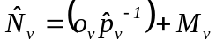 | (1)
where:
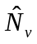 = the total number of permits issued by vendor v,
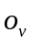 = the number of permits issued by vendor v and returned by permit holders before the first reminder letter, but with no vendor card (the “orphan permits”),
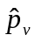 = 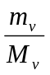, the response rate before the first reminder letter mailing among permits with vendor cards from vendor v,
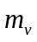 = the number of permits returned before the first reminder letter mailing with vendor cards from vendor v,
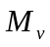 = the total number of permits with vendor cards from vendor v.
With variance estimated as:
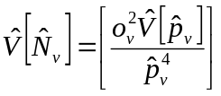 , | (2)
where,
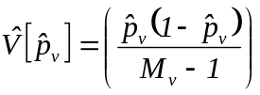 .

The total number of permits issued will be the sum of estimated permits issued by each vendor (including Fish and Game offices):
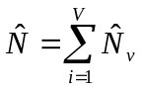. | (3)
The variance of the total number of permits issued will be the sum of the variances for each vendor.
Harvest for each species or participation for each site is estimated by the following procedure (with subscripts denoting parameter of estimation deleted for simplicity):
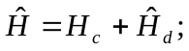 | (4)
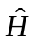 = estimated total harvest or participation;
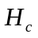 = harvest or participation reported by permit-holders who return their permits before the second reminder letter is mailed in mid-October;
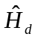 = harvest by non-compliant households = 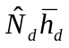 ;
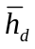 = the mean harvest or participation per household at each site, for non-compliant households; and
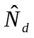 = the total number of non-compliant permits = 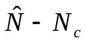, where
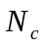 = the number of permits returned before the second reminder letter in mid-October.
The term 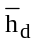, which is the mean value of harvest per non-compliant household, is calculated as follows:
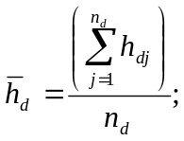 | (5)
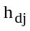 = reported value of harvest by responding non-compliant household j, and
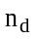 = the number of non-compliant households responding to the reminder mailings.
Variance will be calculated as (Goodman 1960):
, | (6)
where:
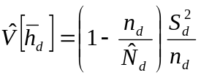 , | (7)
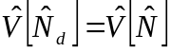, | (8)

and
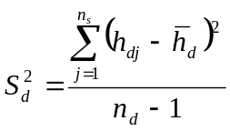 . | (9)
Standard errors are simply the square root of the variance estimate.

SCHEDULES AND REPORTS
The following milestones must be met to keep the survey on schedule:
- 2002 permit designed and reviewed by Analyst Programmer assigned to this project by February 15, 2002.
- Permits for 2002 printed by the last week of March, 2002.
- Permits bundled into groups for each office or vendor by the first week of April. Permits for Anchorage vendors are distributed to vendors by RTS staff and the project biologist. Permits for Mat-Su and Kenai Peninsula vendors are distributed by the area offices and/or the project leader.
- Top copies of 2002 permits will be collected from license vendors by August 31, 2002.
- All permit holder identification information from the top copies of the permits will be keypunched by September 11, 2002.
- Harvest and participation information from initial respondents will be keypunched by September 16, 2002.
- Nonrespondents will be identified and first reminder letter mailed by September 27, 2002.
- Non-respondents from the first mailing will be identified and second reminder letter mailed to the non-respondents by October 25, 2002.
- License numbers and harvest and participation information from respondents to the second reminder will be keypunched by November 18, 2002.
- Final, clean data set, along with metadata and log of the edits will be given to project leader December 6, 2002.
- The summary report will be included in the Upper Kenai Peninsula Area Management Report.

LITERATURE CITED
Goodman, L. A. 1960. On the exact variance of products. Journal of the American Statistical Association 55: 708-713.
Nelson, D., D. Athons, P. Berkhahn, and S. Sonnichsen 1999. Area management report for the recreational fisheries of the Kenai Peninsula, 1995-1997. Alaska Department of Fish and Game, Fishery Management Report No. 99-3, Anchorage.
Table 1.-Number of permits returned by mailing, 1999-2001.
 |  | 1999 | 2000 | 2001
Estimated Number of Permits Issued |  | 17,197 | 16,107 | 16,915
Voluntary Returnsa |  | 52.1% | 50.1% | 50.3%
Returned after first reminder |  | 21.9% | 24.6% | 23.0%
Returned after second reminder |  | 8.6% | 9.6% | 11.7%
Non-response |  | 17.4% | 15.7% | 14.9%
Total |  | 100.0% | 100.0% | 99.9%

a Voluntary households are those that voluntarily returned their completed permits without being mailed a reminder letter.

Table 2.-Sockeye salmon harvest in the upper Cook Inlet personal use fishery, 1999-2001.
Year | Parameter Estimates | Kenai  River  Dipnet | Kasilof  River  Dipnet | Kasilof  River  Gillnet | Fish  Creek  Dipnet | Unknown  Site | Total
1999 | Estimated harvest | 149,504 | 37,176 | 12,832 | 1,083ª
 | Standard Error | 1,084 | 507 | 371 | 138
 | Relative Precision | 1.4% | 2.7% | 5.7% | 24.9%
2000 | Estimated harvest | 98,262 | 23,877 | 14,774 | 6,925 | 5,429 | 149,267
 | Standard Error | 752 | 403 | 275 | 211 | 274 | 900
 | Relative Precision | 1.5% | 3.3% | 3.6% | 6.0% | 9.9% | 1.2%
2001 | Estimated harvest | 150,766 | 37,612 | 17,201 | 436ª | 12,673 | 218,687
 | Standard Error | 909 | 505 | 394 | 40 | 380 | 1,082
 | Relative Precision | 1.2% | 2.6% | 4.5% | 18.0% | 5.9% | 1.0%

a In 1999, Fish Creek was open for only 15 of the regular 21 day season, in 2001 the season was restricted to 3 days of fishing.

Appendix A - 2002 Upper Cook Inlet personal use Salmon Fishing Permit
Appendix A1.-2002 Upper Cook Inlet personal use salmon permit.
Vendor Copy | Permit Number: | 02-
2002 Upper Cook Inlet Personal Use Salmon Fishery

Last Name |  |  |  |  |  | First Name |  | Middle Initial
Mailing Address
City |  |  |  | State |  |  | Zip Code
Phone Number: (907)
Total Number of Household members: |  | Total Allowable Harvest: |  |  | You are allowed 25 fish for the head-of-household, and 10 fish for each additional household member. This is your limit for the entire 2002 season.  Example: a family of 4 is allowed 25+10+10+10=55 fish.

2002 Alaska Resident Fishing License Number: |  |  |  |  |  |  |  |  | Drivers License Number:

Signature of permittee (permit holder) |  | Date
Vendor Signature | Vendor Number:

 |  |  |  |  |  |  |  | Permit Number: |  |  | 02-
2002 Upper Cook Inlet Personal Use Salmon Fishery Permit
Last Name |  |  |  |  | First Name |  |  |  |  | Middle Initial
Names of Other Household Members
Total Number of Household members: |  |  | Total Allowable Harvest: |  |  | You are allowed 25 fish for the head-of-household, and 10 fish for each additional household member. This is your limit for the entire 2002 season.  Example: a family of 4 is allowed 25+10+10+10=55 fish.
This permit is for dipnetting at the mouth of the Kasilof and Kenai rivers and Fish Creek (near Wasilla) and for gillnetting near the mouth of the Kasilof River in 2002. You must have this permit with you while you are fishing, and you must record your harvest before you leave the stream. Check the Sport Fishing Regulation Summary for Cook Inlet for legal times, gear, and harvests.
Check this box if no one in your household fished

Report all days fished and all fish harvested. Record every day you fish, even those days when you didn’t catch anything.
Date | Fishery* (see below) |  |  |  |  | RED | chum |  | King |  |  | COHO | Pink
*Fisheries are: Kenai River Dip Net, Kasilof River Dip net, Fish Creek Dip Net, Kasilof River Gill Net
Return this permit to Fish and Game by August 15 2002. You must return your permit even if you did not fish.

Instructions for Vendors
These permits are free, but are for Alaska residents only. To get a permit the person must have a current Alaska resident sport fishing license. Persons who are exempt from licensing (over age 60, under age 16) must have other identification.
These are household permits. Only one permit is issued per household. Each person who fishes must have a current Alaska resident fishing license (unless exempt).
Be sure all the identifying information is complete on the top and bottom of the form. Don’t let people walk out with blank permits!
To Issue a Permit
Ask to see the applicant’s 2002 Alaska resident sport fishing license. Write the license number in the space provided on the top of the form.

Have the applicant fill out his/her name, address, and driver’s license number on the top and bottom of the form, including names of other household members.

Figure out the household’s total allowable harvest. They are allowed 25 fish for the head-of-household and 10 fish for each additional household member. Write it in the space provided on the bottom half of the form. Sign and date the top and write in your vendor number.

Tear the permit along the perforation. You keep the top, the applicant gets the bottom.

Return your top copies each month to Fish and Game in the envelopes provided. After the last fishery closes in early August, return all unissued copies and all the vendor copies to Fish and Game. These must be returned by Sept. 15, 2002.

Address for return of your vendor copies and unissued permits:
State of Alaska, Department of Fish & Game,
Personal Use Salmon Permits,
333 Raspberry Rd,
Anchorage, AK 99518-1599.

Questions? Call the Sport Fishing Information Center at 267-2218.
_________________________
Place
first-class
Postage
Here


_________________________

_________________________

REMOVE BOTH TIPS OF THE TAIL FIN FROM FISH CAUGHT IN PERSONAL-USE FISHERIES

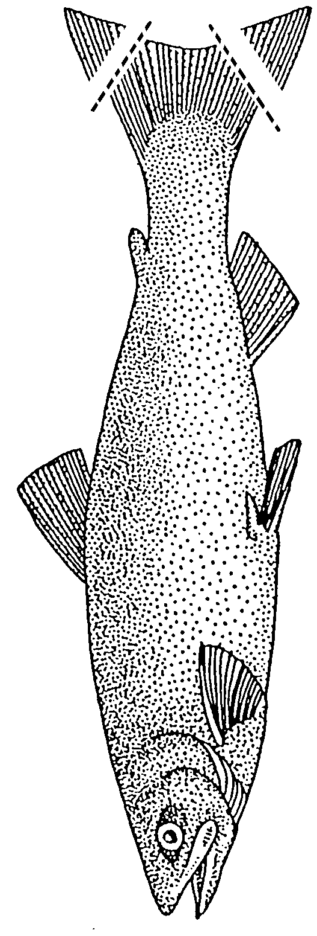STATE OF ALASKA

DEPARTMENT OF FISH AND GAME

Personal Use Salmon Permits
333 raspberry road
Anchorage AK 99518-1599

Appendix B -Reminder letter to be mailed to nonrespondents
Appendix B1.-Reminder letter to be mailed to nonrespondents.

PRST STD
U.S. Postage PAID
Anchorage, AK

STATE OF ALASKA

DEPARTMENT OF FISH & GAME
Personal Use Salmon Permits
333 raspberry road
Anchorage AK 99518-1599

2002 Upper Cook Inlet Personal Use Salmon Fishery-Reminder

Our records show that you have not returned your 2002 Upper Cook Inlet Personal Use Salmon permit. Even if you think you have returned your permit, it has not reached us. Please return the original permit or use the form below.

Remember that you must return the permit even if you did not fish. Failure to return your permit may result in denial of your future personal use harvest privileges.
Total Number of Household members: |  |  | Total Allowable Harvest: |  | You are allowed 25 fish for the head-of-household, and 10 fish for each additional household member. This is your limit for the entire 2002 season.  Example: a family of 4 is allowed 25+10+10+10=55 fish.
Check this box if no one in your household fished
Report all days fished and all fish harvested. Record every day you fished, including days when you did not harvest any fish.
Date | Fishery* |  |  |  | RED | CHUM | KING | COHO | PINK
*Fisheries are: Kenai River Dip Net, Kasilof River Dip net, Fish Creek Dip Net, Kasilof River Gill Net
YOU MUST RETURN YOUR PERMIT EVEN IF YOU DID NOT FISH.

Place
first-class
Postage
Here

STATE OF ALASKA

DEPARTMENT OF FISH & GAME
Personal Use Salmon Permits
333 raspberry road
Anchorage AK 99518-1599

STATE OF ALASKA

DEPARTMENT OF FISH & GAME

Personal Use Salmon Permits
333 raspberry road
Anchorage AK 99518-1599

Appendix C - Cook Inlet personal use Fishing Regulations, 2002

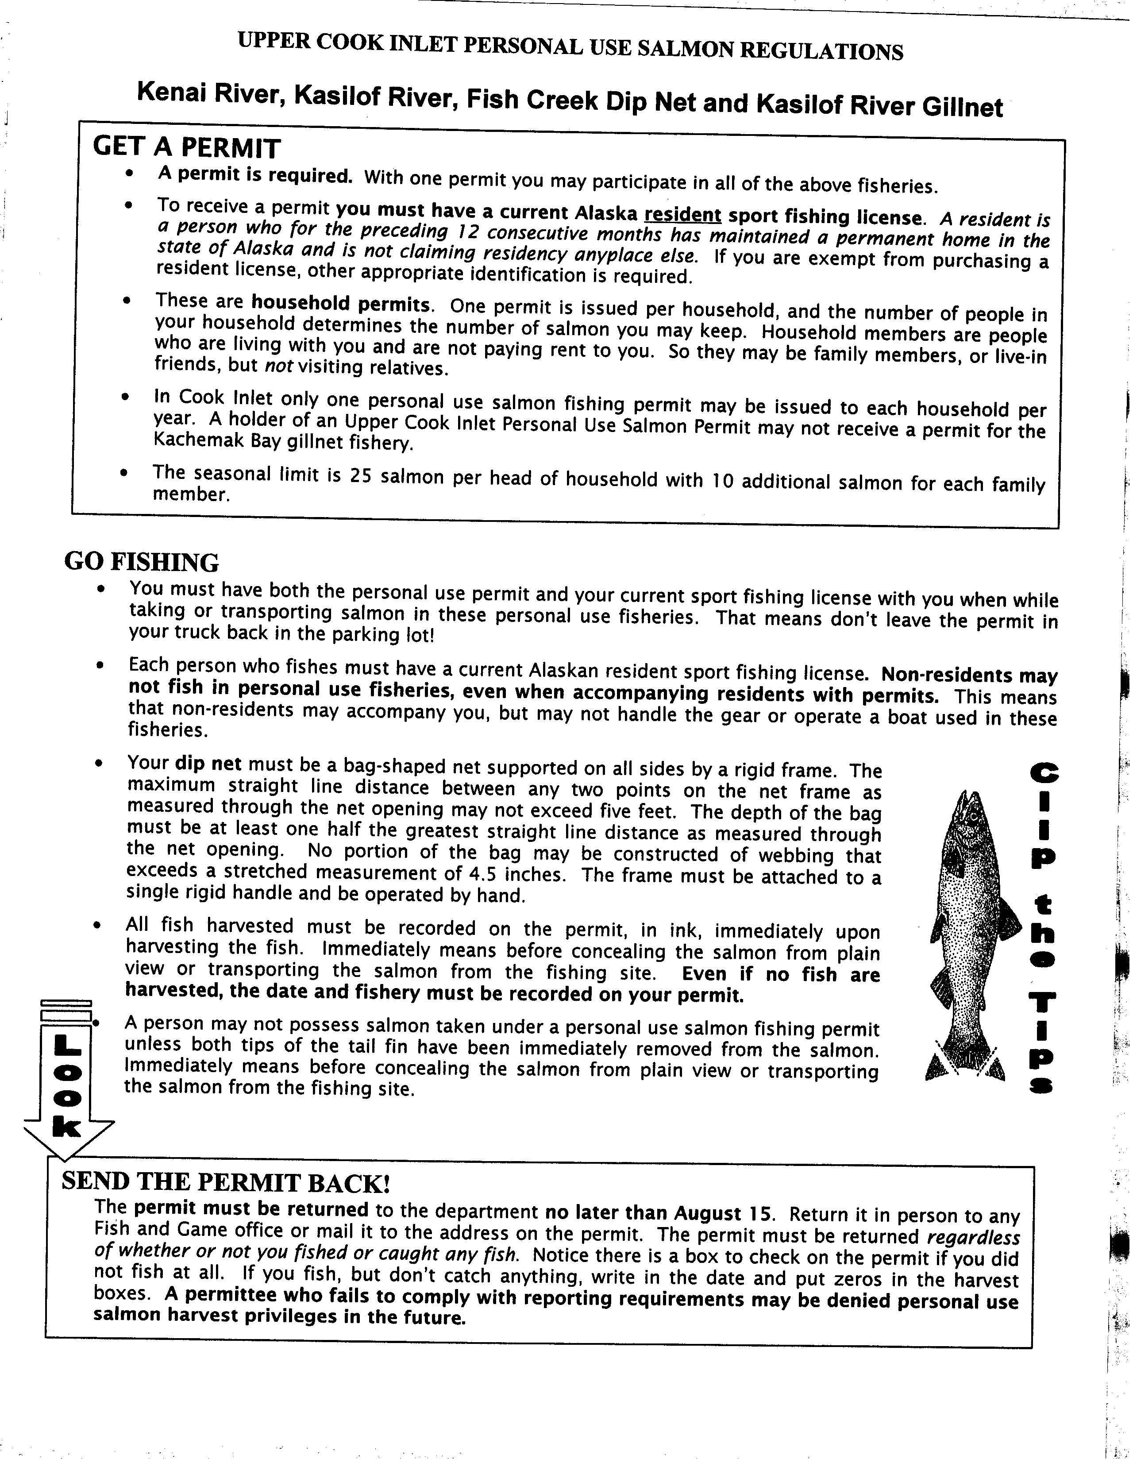

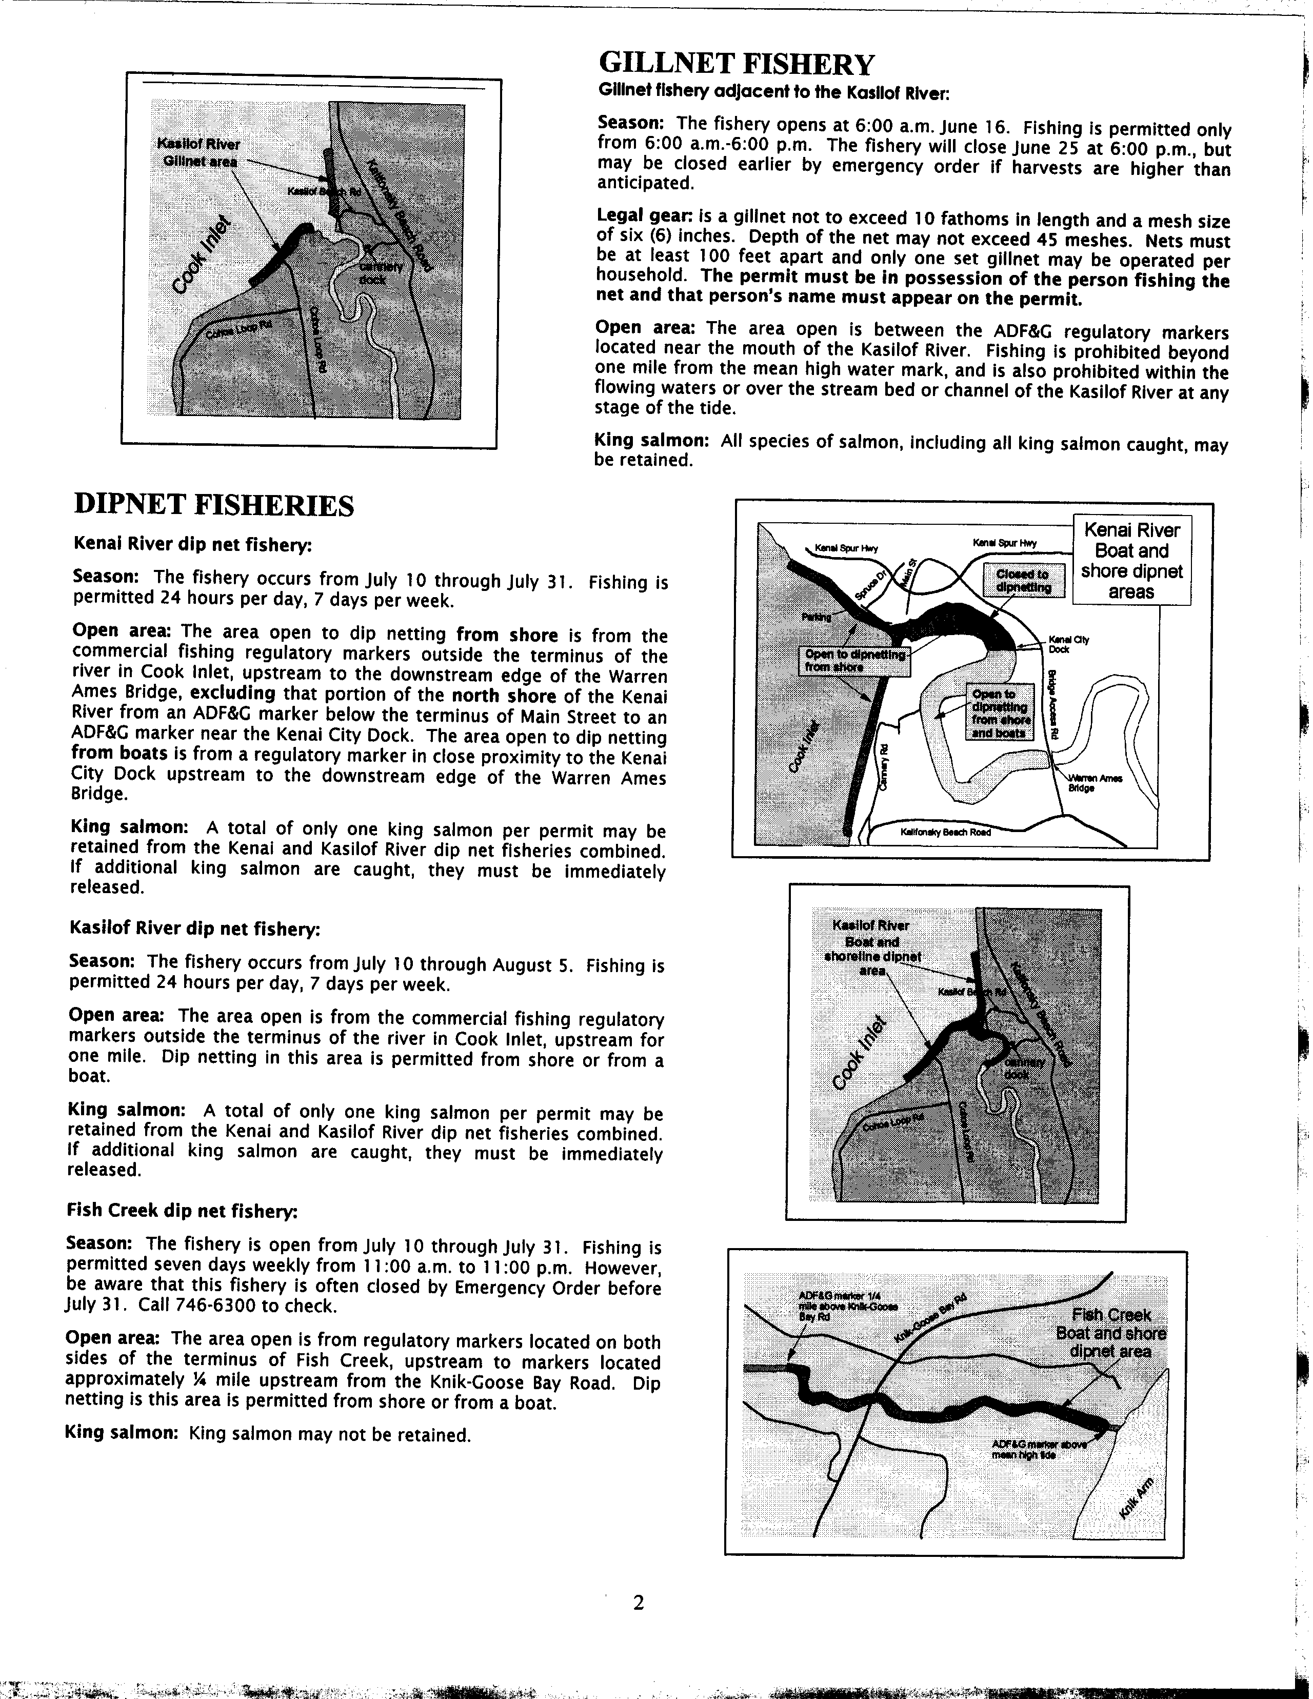

Appendix d - Keypunching instructions
TO BE UPDATED BY THE IM STAFF FOR THE 2001 PERMITS

2001 Cook Inlet Personal Use Salmon

Data Entry Instructions

Overview
The Cook Inlet Personal Use Salmon Project is key punched by the Anchorage ADF&G Sport Fish RTS Data Entry staff using an Intranet based application. The application consists of HTML pages written in Cold Fusion that allow entry, editing and deletion of permit holder and harvest information. Access to this application is through the ADFG Intranet and restricted based on user ID as to what functions are allowed. Data from the entry application goes directly into two MS SQL “raw” tables - one for the permit holder information (CISLPMXX) and one for the harvest information (CISLHVXX). These tables are part of the CISALXX database.

Permit Holder Entry
Access to the Permit Entry system is through the ADF&G Intranet Site Index Main Menu Permits section:

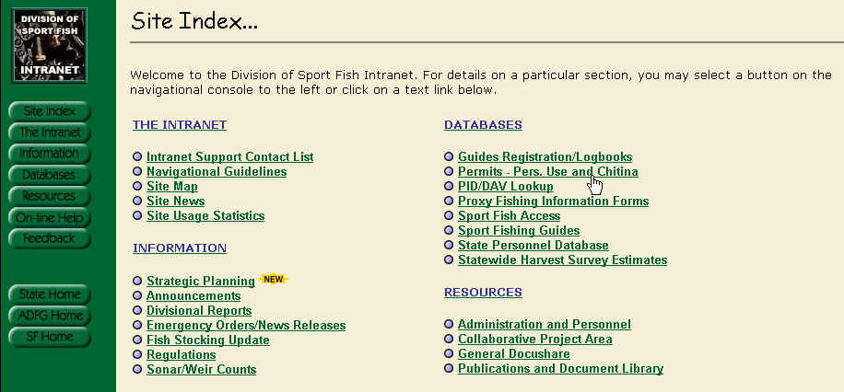

Once selected, you should see the following screen:
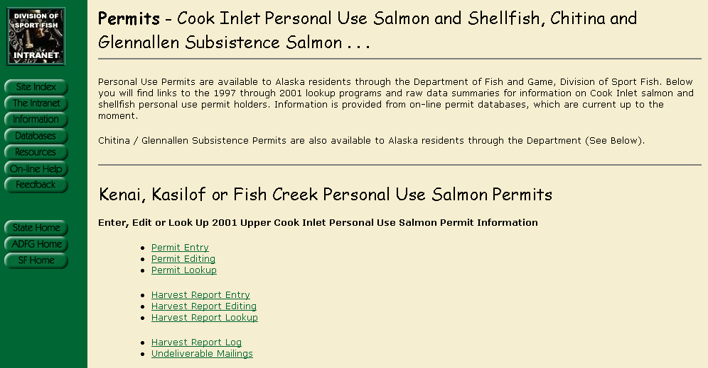

Selecting Permit Entry will bring up a screen in which you enter the Permit Number that is stamped on the bottom right of the Permit itself and whatever ID number that is written in the ADL / ID box on the permit. This number will be searched through the previous years database, PID database and Sports License Database (in that order) to try and fill the applicable fields.

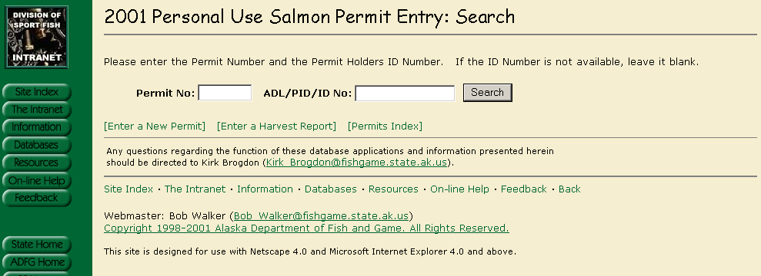

If a record is found, you will see a display showing the Name and ID number as well as an indication as to what Database the information was found. If the Information appears to be the same person that you are entering for, click on any field in the box to auto fill the permit with as much information as possible.

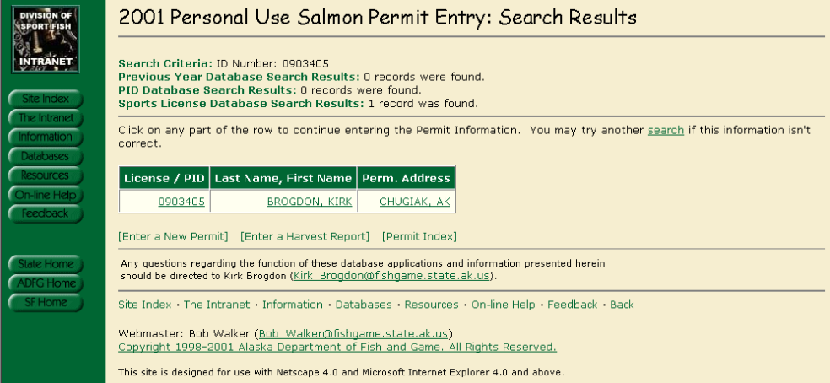
Which should bring up the following screen in which you can complete and/or edit based on the written permit. If there is no information available then the same screen will come up but all of the fields will be blank.
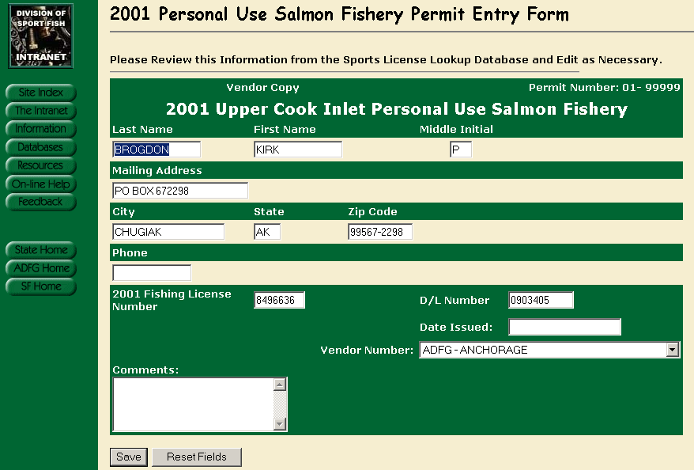

Once filled out, click on the Save button and you should see the following:

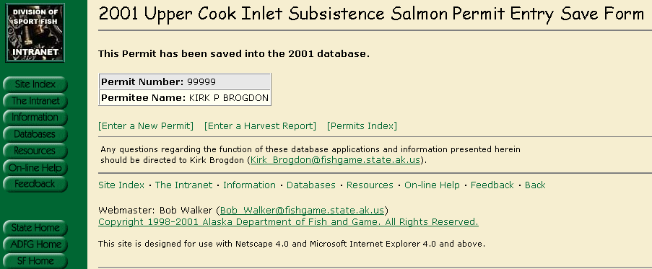

Miscellaneous Permit Entry Notes

Required Fields:
- Date Issued
If the Date Issued is left blank, the Entry Clerk is prompted that it must be filled in and to enter ‘01/01/yyyy’ if the actual permit does not have an issued date on it.

Permit Editing

From the same screen that you select Permit Entry, there is a link for Permit Editing. When selected, you should see a similar screen as the Entry screen plus there will be check boxes for Did Not Fish, Blank Report and No Success.

Permit Lookup

From the same screen that you select Permit Entry, there is a link for Permit Lookups. This screen will display all the Permit Information but will not allow any edits or deletions. There is also a link to display the actual scanned image of a returned Harvest Report.

Harvest Report Entry
From the same screen that you select Permit Entry, there is a link for Harvest Reporting. When selected, you should see the following screen:
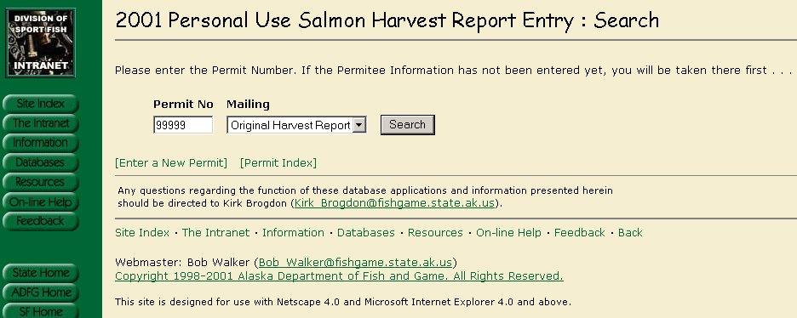
Enter the Permit Number and select the Mailing from the Drop Down list – The default is the original. You should see the following after clicking on Search:
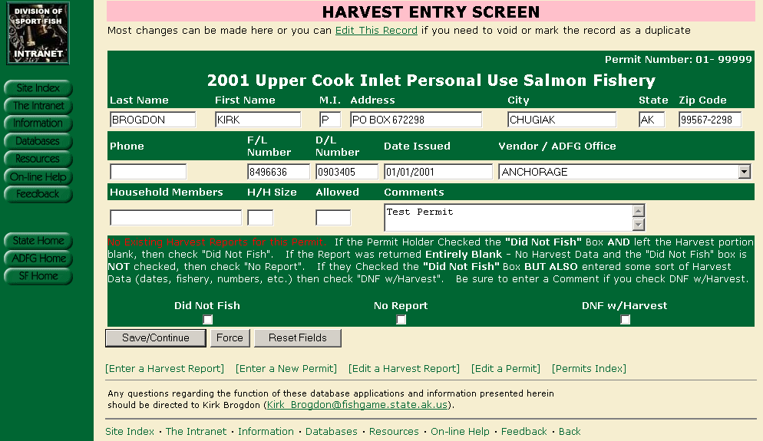

At this point, you have the opportunity to check the “Did Not Fish”, “No Report” (blank) or “DNF with Harvest” boxes – We often receive harvest reports with the “Did Not Fish” box checked but they also enter Harvest (or attempted harvest) information. From the Harvest Report, enter the Allowable harvest, Household size and Household members if available. You can edit any Permit Info shown if necessary, otherwise click on “Save/Continue”.

You should now be on the following screen:

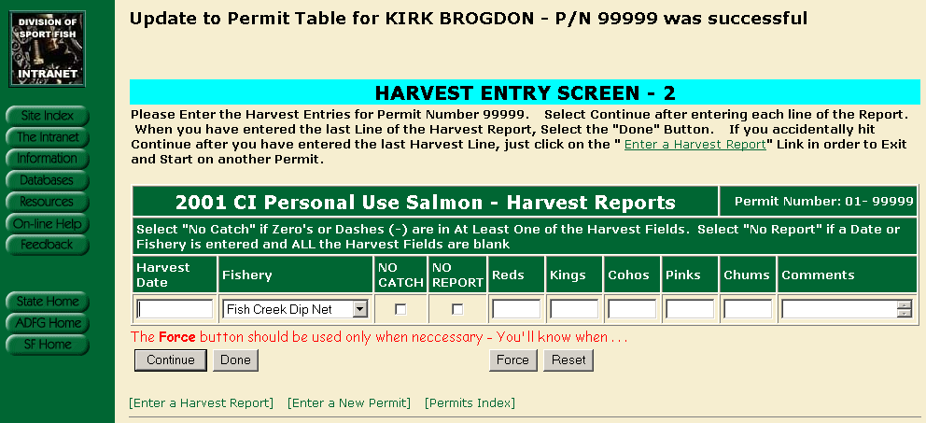

Enter the harvest date as shown on the form. If the date is blank, enter 01/01/1990. If the date shows just the month, enter that month followed by 01/1990. If they have zeros in one or more fields (and nothing else) then that is considered “No Catch” and you should check that box. If they have nothing at all other than a date or location, then that would be considered “No Report” and you should check that box. All of the fields coincide with the actual printed form that the Permit Holder has filled out. This screen is built so that you can enter one harvest record (line) at a time. Once you have entered the line, click on continue. Once you do, you should see the following:

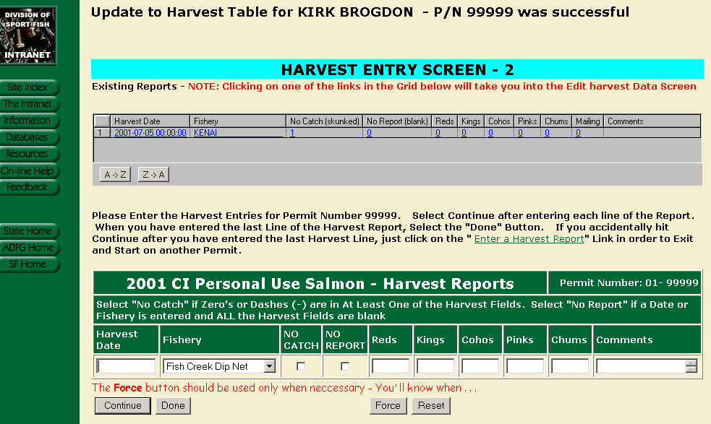

Note that the upper part of the screen shows the harvest entry that you just added (plus any other existing harvest entries for the permit). This upper part of the screen can actually take you into the Harvest edit screen for the permit that you are currently working on (should you realize that you keyed a mistake). Otherwise, keep entering each line of the harvest report until you are on the last one. On the last entry, select “Done” rather than continue (if you click on continue after your last harvest entry, just click on the “Enter a Harvest Report” or one of the other links at the bottom of the page).

Miscellaneous Harvest Report Entry Notes

There are numerous data checks that are performed each time you select “Continue” or “Done” in an attempt to alleviate keying errors. Examples are:

- No harvest numbers entered but “No Catch” or “No Report” is not selected
- “No Catch” or “No Report” is selected but there is a value in one of the harvest fields.
- If any one line totals more than the allowed harvest value

Examples 1 and 2 cannot occur and must be changed. Example 3 could be an actual representation of what is reported and will be accepted if the user submits with the “Force” button. A detailed error message will be presented to the user explaining the problem and how to proceed.

Harvest Reports Returned Before Permit is Entered

It is possible that a permit holder will return their harvest report before an entry is made into the permit table. The following screen will appear if that happens:

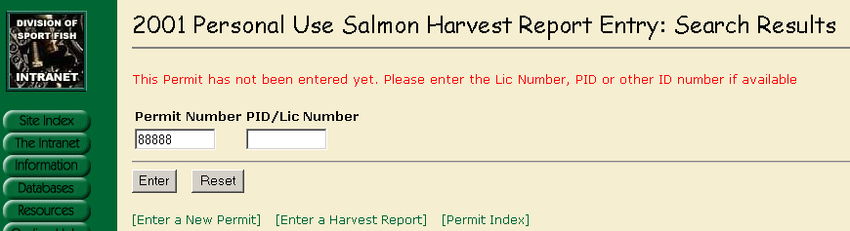

The permit can be entered as normal using the information on the front side of the harvest report. Once that is completed then the harvest report can be entered.

Harvest Report Editing
From the same screen that you select Harvest Report Entry, there is a link for Editing. When selected, you should see the following:
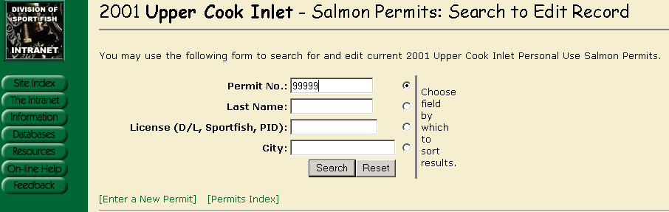
Entering the permit number will bring up the following:
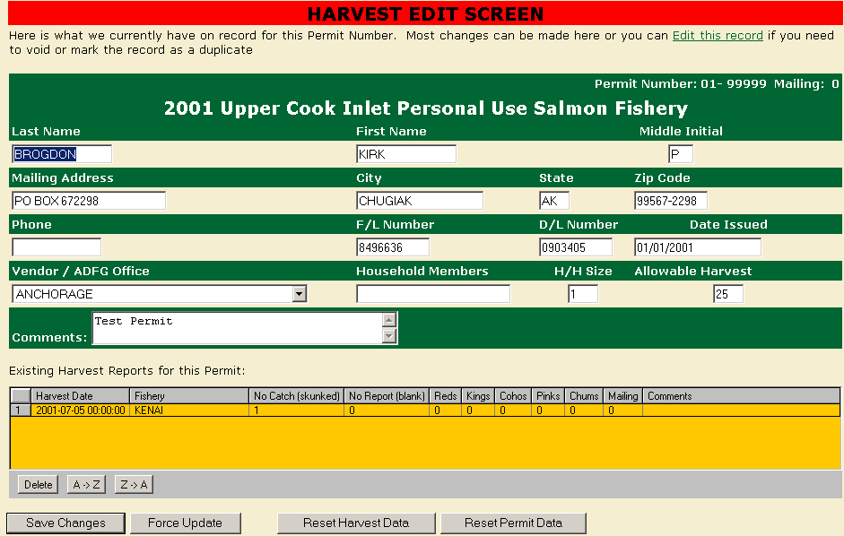
The harvest information can be edited or deleted directly from this screen. If the record needs to be voided, marked as a duplicate or changed to “Did not Fish” or “Blank Report” then the permit itself needs to be edited – not the harvest report. This can be done through the main menu or by using the link at the top of the page (Edit this record).
Note – If harvest data exists then the application will not allow the change to “Did Not Fish” or “Blank Report” until the Harvest Data is deleted.

Appendix E - File Structure for shellfish databases

TO BE UPDATED BY THE IM STAFF FOR THE 2002 PERMITS

Table and Field Information for Database I:\DP\CISALMXX\CISAL_SQL.DBC
Cook Inlet Personal Use Salmon Permit Process - Corrected and Final Data
02/12/2002 - kpbrogdon

Respondent Harvest Table:

Table: CISLHVXXC
Number of records:
Num Field Name Type Width Dec Nulls Default
1 HVRECID I 4 0 No
2 PERMITNO I 4 0 No
3 NOCATCH L 1 0 No
4 NOHRVRPT L 1 0 No
5 HARVDATE T 8 0 Yes
6 RED I 4 0 No
7 KING I 4 0 No
8 COHO I 4 0 No
9 PINK I 4 0 No
10 CHUM I 4 0 No
11 FISHERY C 20 0 No
12 KEYDATE T 8 0 No
13 KEYID C 16 0 No
14 YEAR I 4 0 No
15 MAILING I 4 0 No
16 EDITED L 1 0 No
17 COMMENTS C 20 0 Yes
-----
113

Additional Field Information For Corrected Harvest Table CISLHVXXC:

HVRECID
Comment: Unique Harvest Record ID as copied from the Raw Harvest
Table

PERMITNO
Comment: Permit Holders Permit Number.

NOCATCH
Comment: Flag indicating that an unsuccessful attempt was made on
this particular day.

NOHRVRPT
Comment: A date or fishery was indicated but all harvest fields are
blank - if zeros or dashes are shown, then this would be a
nocatch.

HARVDATE
Comment: Date that the actual Harvest or attempted harvest took
place.

RED
Comment: Total Red salmon harvested on this day

KING
Comment: Total King salmon harvested on this day

COHO
Comment: Total Coho salmon harvested on this day

PINK
Comment: Total Pink salmon harvested on this day

CHUM
Comment: Total Chum salmon harvested on this day

FISHERY
Comment: Valid Fishery - Choices are Kenai, Kasilof or Fish Creek.
All others are recorded as "Unknown"

KEYDATE
Comment: Date that the Harvest report was keyed by Data Entry

KEYID
Comment: Key ID of Data Entry clerk that enters the Harvest Report.

YEAR
Comment: Fishing Year that the Permit is valid for.

MAILING
Comment: Mailing value of the Harvest Report. This can be 0, 1 or 2.
If harvest data is received on different mailings with
identical Harvest

EDITED
Comment: Extraneous field. Not used

COMMENTS
Comment: Misc comments from Data Entry - Any comments enclosed in
[BRACKETS] are programatic changes made during the
conversion process.

Field Information for Corrected Permit Holder Information (XX Pertains to Year)

Respondent Permit Table (Vendor Copy)
Table: CISLPMXXC
Number of records:
Num Field Name Type Width Dec Nulls Default
1 PMRECID I 4 0 No
2 PERMITNO I 4 0 No
3 FIRST_NAME C 15 0 Yes
4 LAST_NAME C 15 0 Yes
5 INITIAL C 1 0 Yes
6 ADLNO C 10 0 Yes
7 LICENSE_NO C 7 0 Yes
8 ADDRESS C 30 0 Yes
9 CITY C 30 0 Yes
10 STATE C 2 0 Yes
11 ZIPCODE C 10 0 Yes
12 PHONE C 13 0 Yes
13 HHMEMBERS C 50 0 Yes
14 FAMILYSI I 4 0 Yes
15 ALLOWED I 4 0 Yes
16 BLANKRPT L 1 0 No
17 NOTFISH L 1 0 No
18 OFFICE C 20 0 Yes
19 DUPPREF I 4 0 Yes
20 KEYDATE T 8 0 Yes
21 KEYID C 15 0 Yes
22 DATEISS T 8 0 Yes
23 MAILING I 4 0 No
24 STATUS C 3 0 No
25 COMMENTS C 50 0 Yes
26 YEAR I 4 0 No
-----
321

Additional Field Information For Corrected Permit Holder Information CISLPMXXC:

PMRECID
Comment: Unique Record ID from the Raw Permit Table

PERMITNO
Comment: Unique Permit Number - Only Permits that responded are
included in the table

FIRST_NAME
Comment: Permit Holders First Name

LAST_NAME
Comment: Permit Holders Last Name

INITIAL
Comment: Permit Holders Middle Initial

ADLNO
Comment: Permit Holders Drivers License Number

LICENSE_NO
Comment: Permit Holders Fishing License Number

ADDRESS
Comment: Permit Holders Street Address

CITY
Comment: Permit Holders Resident City

STATE
Comment: Permit Holders Resident State

ZIPCODE
Comment: Permit Holders Resident Zipcode

PHONE
Comment: Permit Holders Resident Phone Number

HHMEMBERS
Comment: All additional Household Members that are eligible to fish
under this Permit

FAMILYSI
Comment: Permit Holders Total Family Size - This value can be
calculated if it is not filled in by the vendor providing
allowable Harvest and/or HHmembers exist. If not, Family
Size and Allowed are set to NULL

ALLOWED
Comment: Permit Holders Allowable Harvest - This value can be
calculated if it is not filled in by the vendor providing
Family Size and/or HHmembers exist. If not, Family Size and
Allowed are set to NULL

BLANKRPT
Comment: Flag indicating that a Harvest Report was received but was
completly blank. No harvest values and the "Did Not Fish"
box was not checked.

NOTFISH
Comment: Flag indicating that a Harvest Report was received and the
"Did Not Fish" box was checked.

OFFICE
Comment: Issuing ADFG Office or licensed Vendor

DUPPREF
Comment: Permit numbers that refer to this permit as the master

KEYDATE
Comment: Date that the Permit was originally keyed into the Raw data
table.

KEYID
Comment: Keyid of the original data entry clerk that entered the
permit into the raw data table.

DATEISS
Comment: Date that the Permit was issued by either an ADFG office or
a licensed vendor

MAILING
Comment: Mailing value that the Permit Holder responded to. Values
are "0" for the Original, "1" for the First , "2" for the
Second Reminder. Not necessarily the same as what was
physically turned in as an Original will often be sent in
after a reminder is recd.

STATUS
Comment: Harvest Report Status for the permit. "N" indicates Did Not
Fish, "U" indicates Unknown (Blank Harvest Report) and "H"
indicates actual Harvest data was received.

COMMENTS
Comment: Misc Comments. Any comments inside of [brackets] notate
programatic changes from the Raw data to the corrected ( ie:
family size and allowable harvest corrections)

YEAR
Comment: Harvest Year that the Permit reflects.

Non Respondent Permit Holder Information (Permits Issued but no Report Returned):

Table: CISLPMXXZ
Number of records: 14418
Num Field Name Type Width Dec Nulls Default
1 PMRECID I 4 0 No
2 PERMITNO I 4 0 No
3 FIRST_NAME C 15 0 Yes
4 LAST_NAME C 15 0 Yes
5 INITIAL C 1 0 Yes
6 ADLNO C 10 0 Yes
7 LICENSE_NO C 7 0 Yes
8 ADDRESS C 30 0 Yes
9 CITY C 30 0 Yes
10 STATE C 2 0 Yes
11 ZIPCODE C 10 0 Yes
12 PHONE C 13 0 Yes
13 HHMEMBERS C 50 0 Yes
14 FAMILYSI I 4 0 Yes
15 ALLOWED I 4 0 Yes
16 BLANKRPT L 1 0 No
17 NOTFISH L 1 0 No
18 OFFICE C 20 0 Yes
19 DUPPREF I 4 0 Yes
20 KEYDATE T 8 0 Yes
21 KEYID C 15 0 Yes
22 DATEISS T 8 0 Yes
23 MAILING I 4 0 No
24 STATUS C 3 0 No
25 COMMENTS C 50 0 Yes
26 YEAR I 4 0 No
-----
321

Field Information should be identical to CISHPMXXC with the
exception that all records are for Non Respondent Permit Holders.
There should be no Harvest Records, Did Not Fish or Blank Reports
for any permits in CISHPMXXZ. Status value is "Z" as opposed to
"H", "N" or "U".

